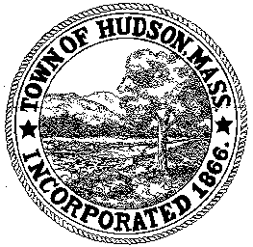

CONSERVATION COMMISSION
78 Main Street, Hudson, MA 01749
(978) 562-2020

Paul Byrne, Chairman W. Minot Wood, Vice Chairman David Esteves, Member

Terrence Joyce, Member Leif Longtine, Member Joseph Rodrigues, Member Al Tashian, Member

Meeting Agenda
November 3, 2011 7:00 P.M.

- Preliminaries
  - Open Meeting
  - Roll Call

2.0 New Business
2.1 DEP 190-0542
Request for Amendment to Order of Conditions
Applicant: Rebecca Mattison
Location: 277 Chestnut Street

2.3 Minutes – October 6, 2011 and October 20, 2011

3.0 Old Business
3.1 Highland Commons Update

3.2 Community Garden Update

3.3 DEP 190-0507 - Update
Request for Certificate of Compliance
Applicant: Jose and Maria Chaves
Location: 4 Third Street

4.0 Correspondence

5.0 Adjournment

Next Meeting: November 17, 2011

